*Seeing Animals and Using Tools*

A brain study on representations of different objects

**Introduction to Cognitive Neuroscience, Aarhus University 12.06.2018**

by

*SIMON MØLLER NIELSEN*

Methods and Results by

*LINE NØRUP,*

*LAURITS DIXEN,*

*LISA SØNDERGAARD*

*& SIMON MØLLER NIELSEN*

Abstract

The organization of knowledge about concepts has long been an area of interest in the study of the mind. Cases of category-specific deficits in semantic memory has hinted at possible structures within the brain for specific categories of concepts. With the advent of functional brain imaging it has been made possible to study these structures in more detail. In this report we try to recreate results of previous studies. We found that, like in previous studies, pictures of animals activate lateral parts of the fusiform gyrus and pictures of tools activate medial parts of the fusiform gyrus. We also showed, unlike previous studies, that pictures of animals activate most of the occipital lobe and small areas of the motor and premotor cortices. This is likely due to mistakes in the setup of the experiment.

*Keywords: Semantic memory; Fusiform gyrus; Premotor cortex; Occipital lobe; fMRI*

Introduction

The main motivator for our understanding of semantic memory comes from patients with category-specific semantic deficits caused by either lesions or dementia (Martin, 2007). It was found that patients were unable to recognize or even cognize about objects from a specific category, like animals, while still retaining most information from another category, such as tools. This distinction between animals and tools is also known as the animate inanimate distinction. This started the idea that objects are organized in different categories which can be damaged individually (Gazzaniga, Ivry & Mangun, 2014). Other types of category-specific deficits also exist, e.g. faces, suggesting that faces may have a distinct category too (De Renzi, 1986). However, the animate inanimate category distinction is the most well explored (Martin, 2007). We will therefore only be looking at those two categories.

There are two main theories for the organization of semantic knowledge in the brain. In the theory of object property organization concepts are not stored in specific areas of the brain, but draw upon multiple areas of the brain from different modalities. Concepts can be associated with both visual features and how they are manipulated, drawing upon the visual and motor cortices respectively. Some objects are associated more with how they look, like animals. Other objects are associated more with how they are manipulated, like tools. This would account for category specific agnosia, since lesions to the motor cortex could still leave you with sufficient information left in the visual cortex to be able to identify animals. The other theory is a domain-specific model in which categories are organized by evolutionary history. So, categories of concepts could be animals, conspecifics and maybe tools, since it is important for our survival to quickly recognize if an object is a member of a dangerous animal group. Within these systems the information can then be organized via properties. This would also account for category specific agnosia, since lesions to a system that organizes information about animals could still leave information about tools intact. However, according to newer neurological studies it seems most likely that concepts are organized solely by property. Seeing as there is a considerable overlap in the systems used for acting and perceiving an object, as well as knowledge about that object (Martin, 2007).

One thing is clear however, concepts are stored in categories. These categories might even influence how we think. Children were found to generalize about features of one apple to all apples, while not doing so for a cup (Gelman & O'Reilly, 1988). The other way around, children generalized about functions for cups, but not functions for apples. These differences might be explained by the number of visual to functional descriptors we use to describe objects from different categories (Farah & McClelland, 1991). Living objects were found to be described with a ratio of visual to functional features of 7.7:1, where non-living objects had a ratio of 1.4:1. This ties into the theory of property organization, since objects drawing mostly upon visual features would use mostly visual systems. This would also explain why it is easier for children to generalize about visual features for things mostly associated with such features.

The question is then which brain areas are then associated with visual features and which is associated with function? Neurological studies of patients with semantic dementia had lesions to their anterior temporal lobes (Hodges & Patterson, 1996). Semantic dementia was strongly related to damage to the ventral occipitotemporal cortex (Williams, Nestor & Hodges, 2005). This has given the idea that semantic memory is associated with the occipitotemporal cortex.

But how do you then account for category-specific semantic deficits? Functional brain imaging scans has allowed us to look closer at the occipitotemporal cortex. Many studies have shown that there is a structure to the occipitotemporal cortex that relates to categories (Martin, 2007). Of special interest, it has been shown that there is a lateral/medial distinction in the posterior temporal cortex and anterior occipital lobe, known as the fusiform gyrus (Chao, Haxby & Martin, 1999). Lateral portions of the fusiform gyrus were more activated when viewing animals, with more medial portions activated for tools. Other distinctions exist too, like that of faces and places (Martin, 2007).

However, this does not mean that this is the only area involved in semantic memory. The same systems that are used for actions are also used to think about those actions. Studies have also found that the left premotor cortex was involved in naming tools, while naming animals showed more activation in the left medial occipital lobe (Martin, Wiggs, Ungerleider & Haxby, 1996). The same regions used for planning movement and processing of vision respectively. One might think that they can associate a lot of movement to animals and that this movement would also incur activation in the motor cortex. However, it has been shown that the movement of animals and tools are processed differently (Beauchamps, Lee, Haxby & Martin 2003). Movement of animals, so called biological motion, showed increased response in the posterior superior temporal sulcus and the lateral parts of the fusiform gyrus. Movement of tools on the other hand, showed increased response in posterior middle temporal gyrus, medial parts of the fusiform gyrus and left parental and ventral premotor cortices. The answer for this might be that movements produced by animals are more smooth, where movements by tools are more rigid. It also ties into the fact that the premotor cortex is used for producing the kinds of movements one would use with tools. Whereas people do not have the same experience producing the same movement as animals.

We are interested in testing these results in our experiment. So, in view of previous results we propose two hypotheses for difference in brain activation between viewing animals and tools. First, we expect that viewing pictures of animals will activate more lateral parts of the fusiform gyrus and pictures of tools will activate more medial parts of the fusiform gyrus. Secondly, we expect there to be more activation in the left medial occipital lobe when viewing animals and more activation in the left premotor cortex when viewing tools.

Methods

*Procedure and design*

A few days before the experiment the participant underwent a pre-scan to make sure the participant was healthy and comfortable in the scanner. Before the experiment, the participant was informed of her rights and last-minute security measures were taken.

Our experiment used a block design with two conditions, 30 seconds per block, 2 seconds per stimulus and 12 minutes in total. The participant completed the experiment two times. The stimuli were divided into two separate sets per condition (e.g. Animals1, Animals2) and shown in a random order within the sets. We had the participant do a light task to keep her focused. For each stimulus, the participant was asked to evaluate if the object on the picture was larger than the previous object. In the scanner the participant had to press a button to report if the object was larger or not. This was to make sure the participant was actively thinking about what was on the pictures and to make sure the participant did not get too bored during the experiment. Before the experiment started we gave the impression this was the point of the experiment, to make sure the participant was focused on the task.

Afterwards a debriefing was performed in which the participant was calmly told we only collected the fMRI data. The experiment was set up in PsychoPy.

*Materials*

We used 60 carefully chosen pictures as stimuli. They were all black outlines on a gray background and was picked to be as comparable as possible. We tried to get all pictures to have the same amount of black and grey but were not completely successful.  Some pictures had more lines or thicker lines (as seen in the example) and were therefore a little different. All pictures were resized to have the same dimensions.

The animate condition consisted of different animals, in some of which you could see the face of the animal. The inanimate condition consisted of pictures of kitchen utensils and other traditional tools, some were electrical.

We used a MAGNETOM Trio fMRI machine at Aarhus University Hospital to run the experiment.

*Example of stimuli in the two conditions*

|  |  |
| --- | --- |
| Animals | Tools |
| https://lh5.googleusercontent.com/IcqBabfn5fhrV8KKzLgsRTz83A9sazexALO7nudJjNZv1B4RqrJumE_kmzXaFquV6UjXHnj64l1lU5Bleul-gC4jElHMs5lsrDkW5hsKYyZF6dq3Ua1_K0YFCUkBPhrbyKnlTSqY | https://lh3.googleusercontent.com/OBKgRwgoS7m9YWlmSV96KGM_-nDO4mdI9LluTLGZu7imETr0K08Lelja8LF9LBkEIuzETFZkRL3DwiE0K8eaFm01GBKaxfybWum-BO97kkZ9N_VFaLaLutWLXF8MUc0Y78Q-U9EA |

*Participants*

There was only one participant in this experiment. A randomly selected 21-year old, right-handed female, who is a cognitive science student. Before the run of the experiment, she underwent a pre-scan.

*Data processing*

All data processing was performed in SPM12 (SPM122015).

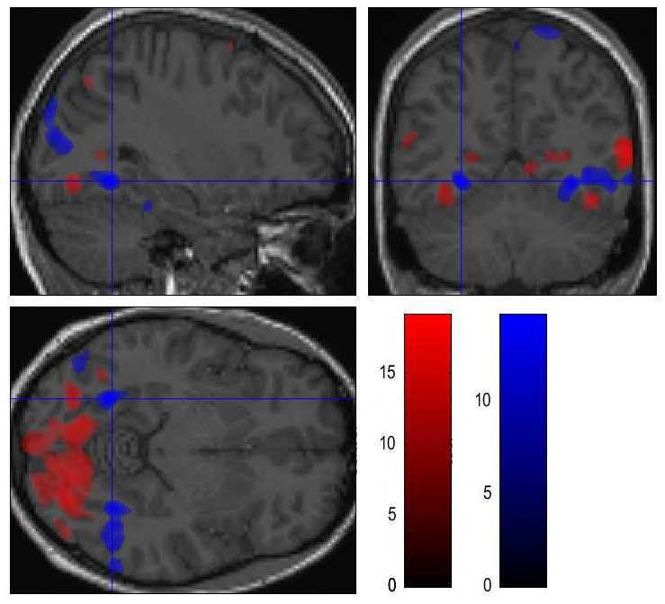Results

As can be seen in figure 4, pictures of animals activated large portions of the occipital lobe at a p < .05 FWE corrected. With peak activation in the posterior areas of the occipital (z-score = Inf, x = -39 , y = -66, z = 25).   
Bilateral activation was found in the lateral parts of the fusiform gyrus (see figure 1 and 2), with peaks in (z-score = Inf, x = -31 , y = -69, z = 44) and (z-score = Inf, x = 40 , y = -74, z = 43). Spots of activation were found in other areas of the brain, but mostly in the middle frontal gyrus (z-score = 7.10, x = -44 , y = 9, z = 56) as seen in figure 6.

Tools

Animals

Figure 1: Comparing activation in fusiform gyrus

*Zooming in on the fusiform gyrus, contrasting the two activations against each other.*

*Red is the animal condition, blue is the tool condition. Notice that the tool condition causes activation more to the anterior and medial than the animal condition.*

Looking at the figure 5 of activation in the tool-condition, tools seem to activate more anterolateral parts of the occipital lobe, especially in the left hemisphere (z-score = Inf, x = -40 , y = -90, z = 17). Strong bilateral activation was found in the more medial parts of the fusiform gyrus (see figure 1 and 3), peaking in (z-score = Inf, x = -29 , y = -58, z = -8) and  (z-score = Inf, x = 32 , y = -56, z = -10).

**Brain activation in three areas**

1. 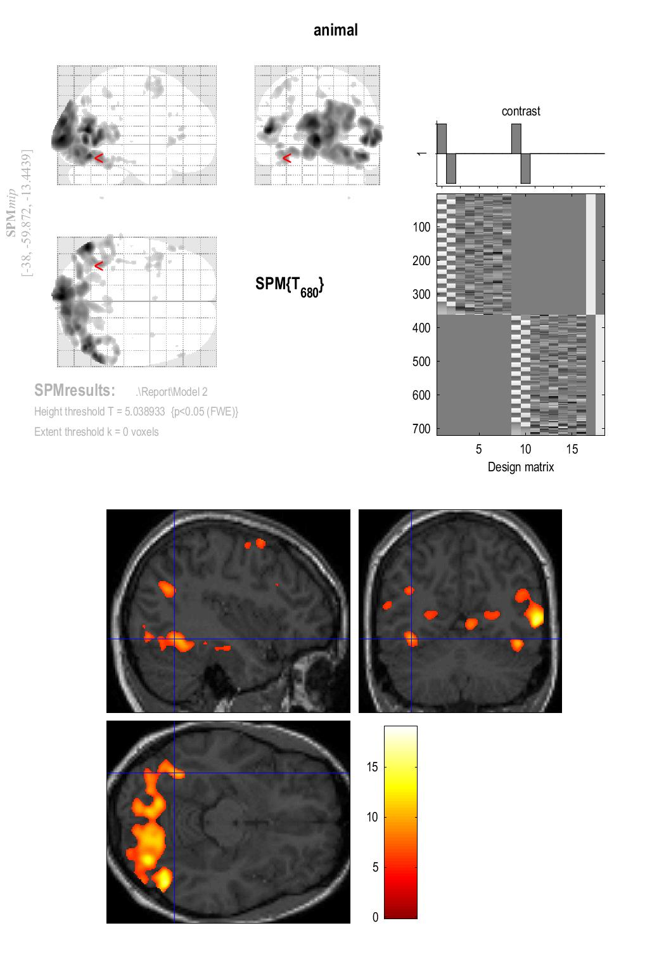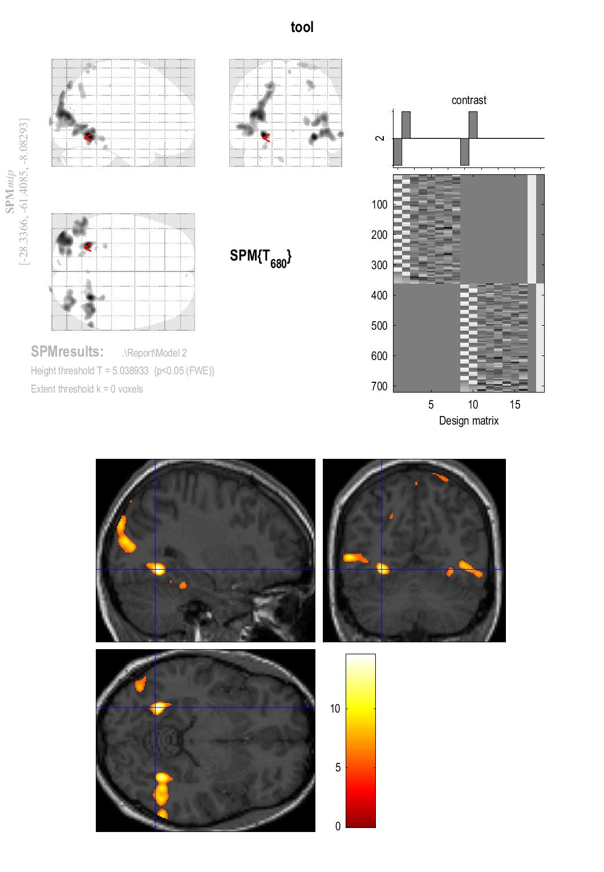**Fusiform gyrus**

Figure 2: Fusiform gyrus activation for animals

Notice large activation in lateral areas of the fusiform gyrus and in the occipital lobe (primary visual areas).

Figure 3: Fusiform gyrus activation for tools

Here we also find activation in fusiform gyrus. This activation is different from the animal condition by being more medial.

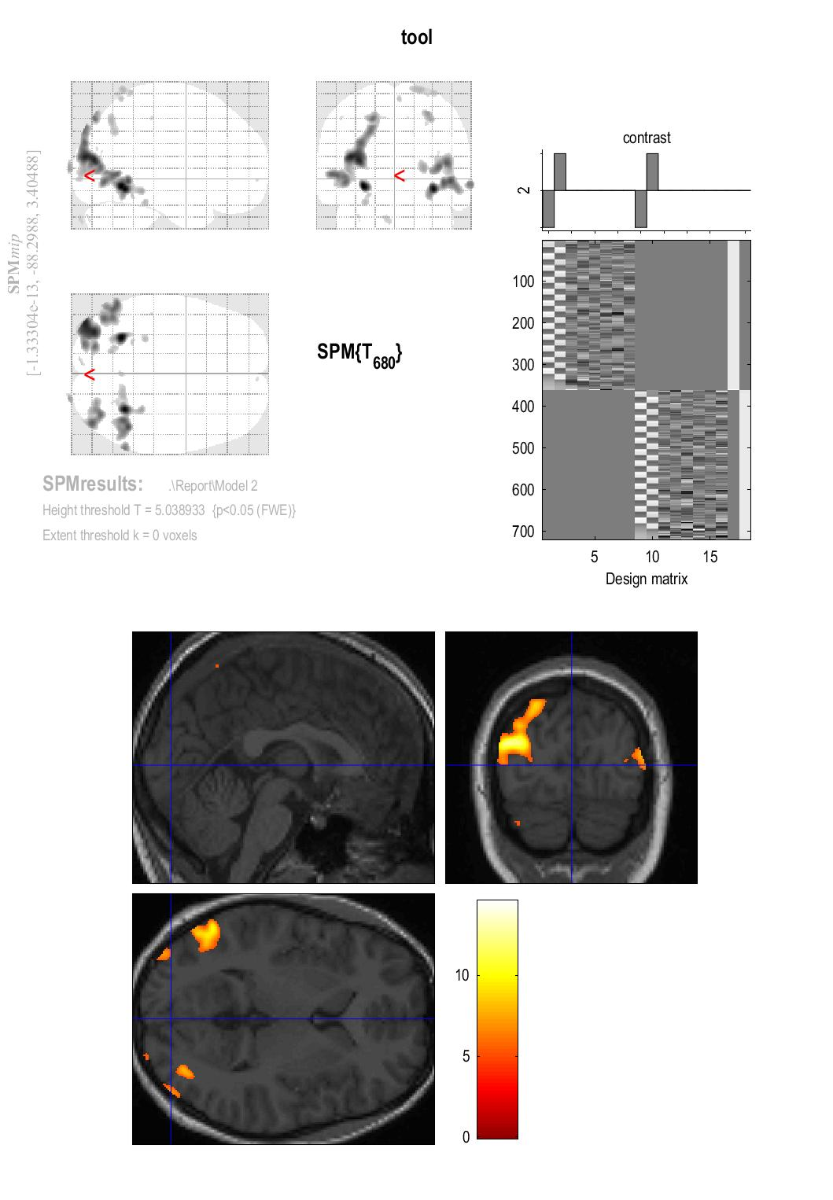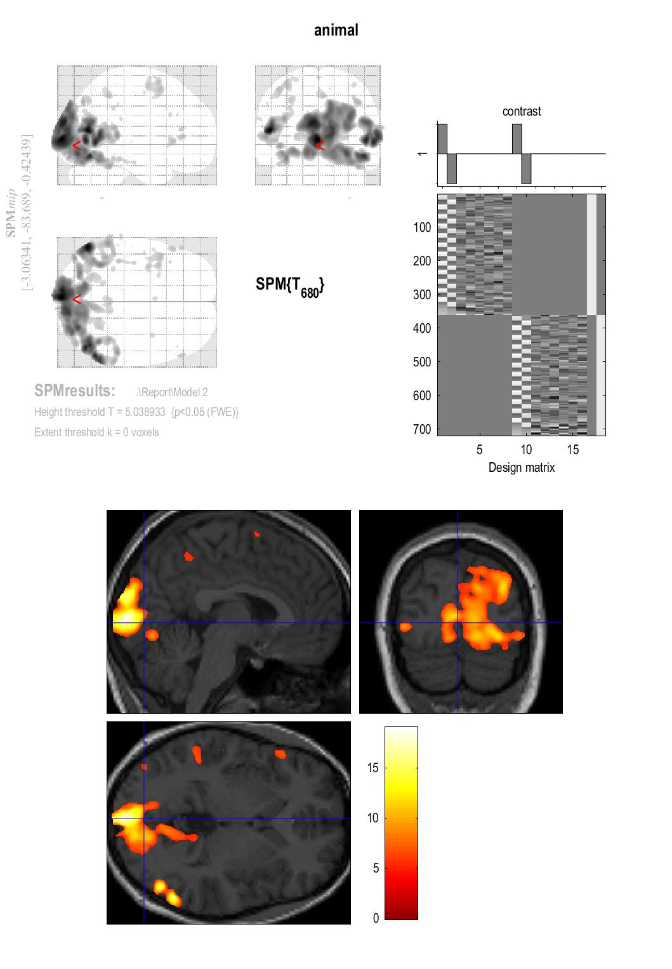**2. Occipital lobe**

Figure 5: Occipital lobe activation for tools

Activation of the occipital lobe is much less for tools.

Figure 4: Occipital lobe activation for animals

Large activation of the occipital lobe can be seen.

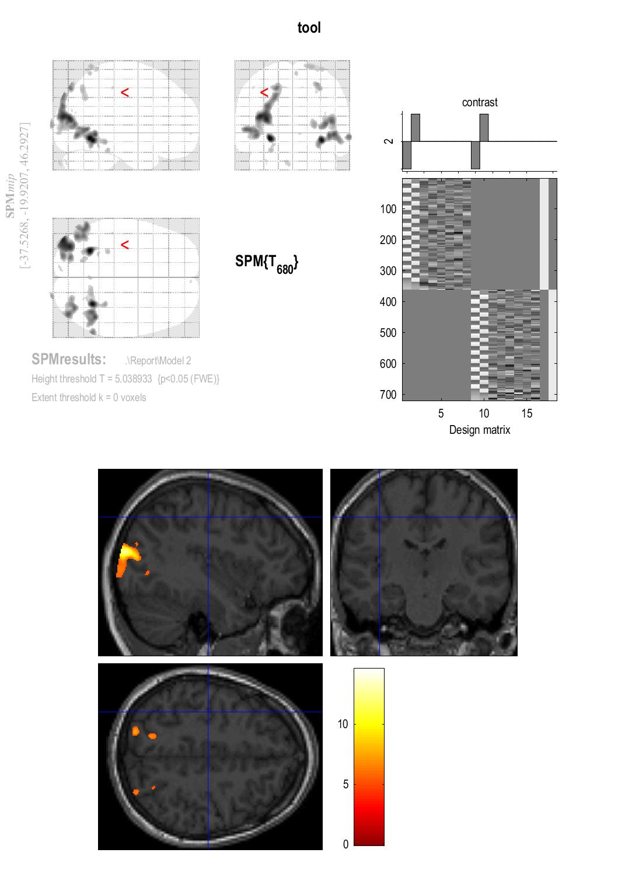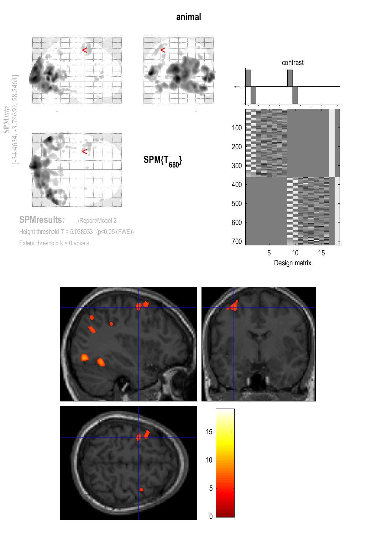**3. Motor cortex**

Figure 7: Motor cortex activation for tools

No increased activation in motor or premotor cortices can be seen.

Figure 6: Motor cortex activation for animals

Activation in motor and premotor cortices can be seen.

Discussion

Our hypothesis about the lateral/medial distinction in the fusiform gyrus seems to hold true. We did indeed find that pictures of animals increased activation in lateral parts of the fusiform gyrus, while pictures of tools activated more medial parts. However, our results did not fit with our hypothesis about the premotor cortex and occipital lobe. In fact, we found the opposite in the premotor cortex, with animal pictures increasing activation. We do see a lot more activation in the occipital lobe when viewing animals. However, this activation is throughout most of the occipital lobe. This suggests that there might be another reason for the activation, other than the picture being of an animal.

This wide activation in the occipital lobe is most likely due to strictly visual differences between pictures of the two conditions. It is well known that visual features such as brightness and detail can have an influence on the amount of activation in the occipital lobe, since this is the primary visual area (Martin et al., 1996). Differences in detail is the likely cause of this activation in our experiment, since all the pictures were black and white. To test this we ran a Welch Two Sample t-test on the means of the file sizes of the pictures of the two conditions. We found the there was a significant difference between the two means t (45.496) = 4.6295, p < 0.001. Looking at the means, the animal pictures had a larger mean of 89.1 KB compared with the picture of tools with a mean of 63.3 KB. Therefore, the likely explanation to the occipital lobe activation is that the animal pictures were more complex.

The motor and premotor cortex activation when viewing animals is puzzling though. This goes against our hypothesis and the results of previous studies. It is therefore likely that this is due to some unknown variable. Though just speculation, an answer could be differences between the conditions that could lead to differences in how much processing the bottom-presses needed. Perhaps judging the size of animals was harder. However, a better understanding of this would require a thorough analysis of the behavioral data, which we have not looked further into.

Another and perhaps more interesting answer to the motor cortex activation is that of the experience of the participant. It has been shown in previous experiments that the meaning we attribute to an object can directly influence the way it is processed (James & Gauthier, 2003). It was shown that when participants were taught to associate specific features with novel creatures, it increased activation in the region of that modality. This has also been shown with novel tools (Weisberg, Van Turennout & Martin, 2006). This means that if the participant did not know some of the tools or animals it could impact the activation. We did not, however, ask the participant about this information, so it is not possible to say anything on these grounds. I bring it up mostly to motivate gathering information about the participants previous experience with the objects shown in a new experiment, as it may have a big influence in the resulting brain activity.

This brings me to the limitations of the experiment. This is mainly that we only tested one participant. You will need more participants to make a strong conclusion. In fact, it is not possible to say anything generalizable with just one participant. It is likely that with more participants the strange activation throughout the brain, like that in the motor and premotor cortices, would disappear. As more data would lessen the impact of small variables.

With respects to further experiments, a lot of studies have already been made into this subject from many different angles and use many different techniques (Martin, 2007). So, it is unlikely that another experiment will reveal something new. However, if this experiment was to be conducted again, the main things to take away from this experiment is that it should be conducted with more participants. More care should also be given to making the pictures visually equal. Lastly as discussed, information about participants prior experiences should be collected.

That is not to say that this area is not of interest. There are plenty of things which we still do not know about semantic memory. Like how activity is coordinated or how these systems interact with the prefrontal cortex (Martin, 2007). Furthering our understanding could one day enable us to read people’s thoughts, simply by analyzing which brain areas are activated (Gazzaniga et al., 2014). This would require further mapping of brain regions which are involved in processing specific categories and perhaps most importantly mapping how differences within the categories are processed. There is therefore plenty of room for further studies within this subject, which could lead to some remarkable new technologies.

Conclusion

In conclusion we found that pictures of animals increased activation in lateral parts of the fusiform gyrus and pictures of tools increased activation in medial parts of the fusiform gyrus. We found wide activation in the occipital lobe when viewing animals, however, this was likely due to the pictures of the animals being more complex. Activation in the motor cortex was also found when viewing animals, which was likely due to an unknown variable. With the limitation of the experiment it is impossible to really conclude anything from this experiment, other than that fMRI experiments require a lot of care be given to the stimuli and proper post experiment analysis may be a useful tool for understanding the results of further studies.

References

Beauchamp, M. S., Lee, K. E., Haxby, J. V., & Martin, A. (2003). FMRI responses to video and point-light displays of moving humans and manipulable objects. *Journal of cognitive neuroscience*, *15*(7), 991-1001.

Chao, L. L., Haxby, J. V., & Martin, A. (1999). Attribute-based neural substrates in temporal cortex for perceiving and knowing about objects. *Nature neuroscience*, *2*(10), 913.

De Renzi, E. (1986). Prosopagnosia in two patients with CT scan evidence of damage confined to the right hemisphere. *Neuropsychologia*, *24*(3), 385-389.

Farah, M. J., & McClelland, J. L. (1991). A computational model of semantic memory impairment: modality specificity and emergent category specificity. *Journal of experimental psychology: General*, *120*(4), 339.

Gazzaniga, M. S., Ivry, R. B., & Mangun, G. R. (2014). Object Recognition. In *Cognitive Neuroscience: The Biology of the Mind* (4th ed., pp. 218-271) New York, W. W. Norton and Company

Gelman, S. A., & O'Reilly, A. W. (1988). Children's inductive inferences within superordinate categories: The role of language and category structure. *Child development*, 876-887

Hodges, J. R., & Patterson, K. (1996). Nonfluent progressive aphasia and semantic dementia: a comparative neuropsychological study. *Journal of the International Neuropsychological Society*, *2*(6), 511-524.

James, T. W., & Gauthier, I. (2003). Auditory and action semantic features activate sensory-specific perceptual brain regions. *Current Biology*, *13*(20), 1792-1796.

Martin, A. (2007). The representation of object concepts in the brain. *Annu. Rev. Psychol.*, *58*, 25-45.

Martin, A., Wiggs, C. L., Ungerleider, L. G., & Haxby, J. V. (1996). Neural correlates of category-specific knowledge. *Nature*, *379*(6566), 649.

Weisberg, J., Van Turennout, M., & Martin, A. (2006). A neural system for learning about object function. *Cerebral Cortex*, *17*(3), 513-521.

Williams, G. B., Nestor, P. J., & Hodges, J. R. (2005). Neural correlates of semantic and behavioural deficits in frontotemporal dementia. *Neuroimage*, *24*(4), 1042-1051.